# Version III

FOR the typical British worker, wages still haven’t returned to their peak in 2009. It has often been taken for granted that, when it comes to wage growth and rising living standards, labour productivity – that’s what the average worker produces in an hour – is everything. Or, as Paul Krugman, winner of the 2008 Nobel Prize in Economics, puts it, “almost everything.”

If this is the case, British wage growth is in trouble. In a conundrum called the ‘[productivity puzzle](https://www.economist.com/britain/2022/06/09/britains-productivity-problem-is-long-standing-and-getting-worse)’, labour productivity in the almost two decades since the 2008 financial crisis has remained flat, as seen in Chart 1, much to the disappointment of policy makers.

[[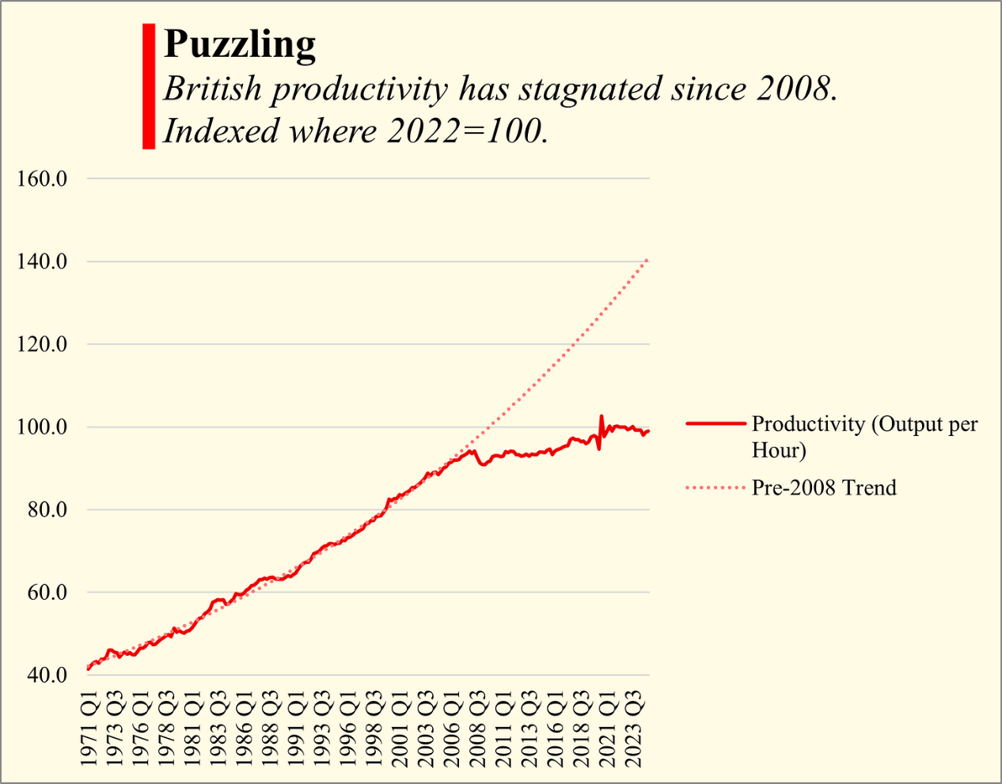](https://substackcdn.com/image/fetch/$s_!azvG!,f_auto,q_auto:good,fl_progressive:steep/https%3A%2F%2Fsubstack-post-media.s3.amazonaws.com%2Fpublic%2Fimages%2F9e8dca20-287c-4e00-92d2-6974c4655505_1995x1567.png)](https://substackcdn.com/image/fetch/$s_!azvG!,f_auto,q_auto:good,fl_progressive:steep/https%3A%2F%2Fsubstack-post-media.s3.amazonaws.com%2Fpublic%2Fimages%2F9e8dca20-287c-4e00-92d2-6974c4655505_1995x1567.png" \t "_blank)

*Chart 1 – Own illustration. Source: ONS.*

Indeed, while earnings growth, and by extension living standards, was intertwined with productivity growth, their disconnection after 2008 is impossible to miss – see Chart 2.

[[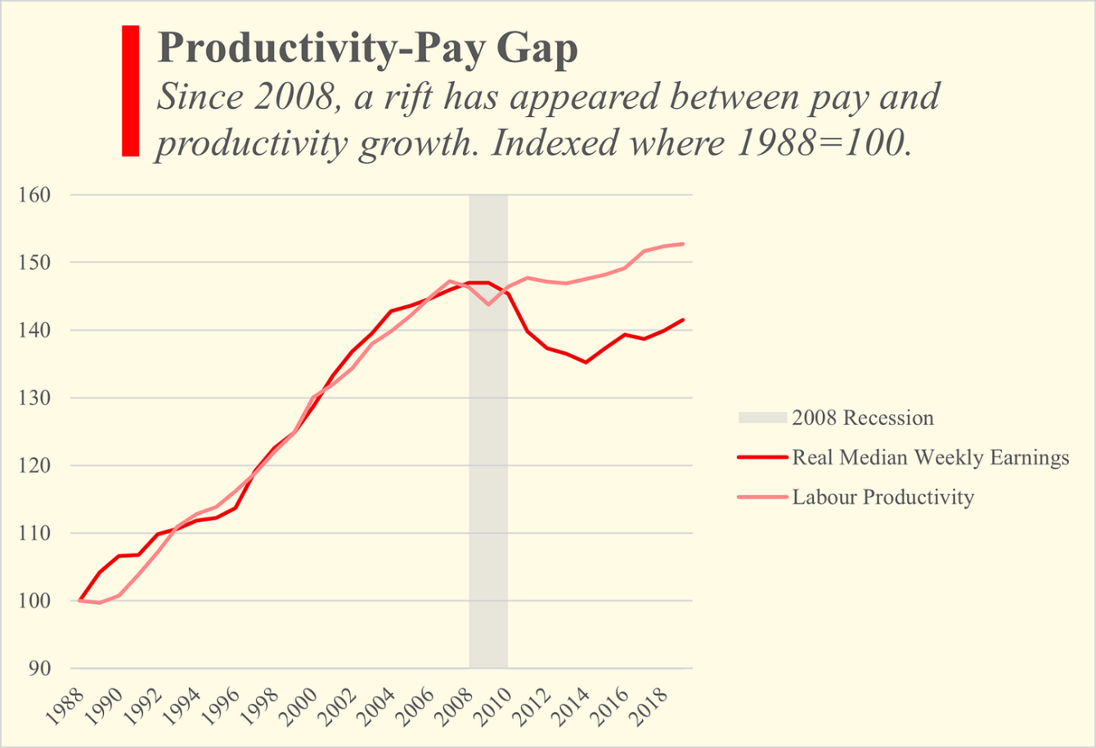](https://substackcdn.com/image/fetch/$s_!ftfN!,f_auto,q_auto:good,fl_progressive:steep/https%3A%2F%2Fsubstack-post-media.s3.amazonaws.com%2Fpublic%2Fimages%2Fe276c555-997b-42fa-b225-769772fd5f96_2001x1372.png)](https://substackcdn.com/image/fetch/$s_!ftfN!,f_auto,q_auto:good,fl_progressive:steep/https%3A%2F%2Fsubstack-post-media.s3.amazonaws.com%2Fpublic%2Fimages%2Fe276c555-997b-42fa-b225-769772fd5f96_2001x1372.png" \t "_blank)

*Chart 2 – Own illustration. Source: ONS*

Chart 2 shows median earnings, which better represent the income of a typical employee than the average (i.e., mean), because they are not biased upwards by exceptionally high earners. The productivity-pay gap, a term coined by the Economic Policy Group, an American worker-oriented, non-partisan think tank, is the rift that has opened up between the growth of the two metrics across much of the Western world. It’s been widening in the US since the 1980s, but like many American phenomena it wasn’t too long before it gained a foothold in the UK and Europe.

Researchers have tried to understand the causes of the discrepancy following the recession. Professor John van Reenen, who now acts as an economic advisor to the Chancellor of the Exchequer, Rachel Reeves, published a study with co-author Andreas Teichgraeber in 2021 suggesting that the two main reasons for decoupling have been growing inequality and the rise of non-wage benefits.

It may come as a shock, then, that since 2014 Britain’s wage growth has outpaced her neighbours and much of the OECD. Combining median wages from the HMRC’s PAYE database, US median wages from those aged 16 and over, and mean wages from a broad basket of high-income countries, and controlling for inflation, the UK manages to edge out the US by 2 points, with British wages 13% higher than they were 10 years ago. Denmark, the next closest contender, finished 6 points lower with 7.5% growth.

[[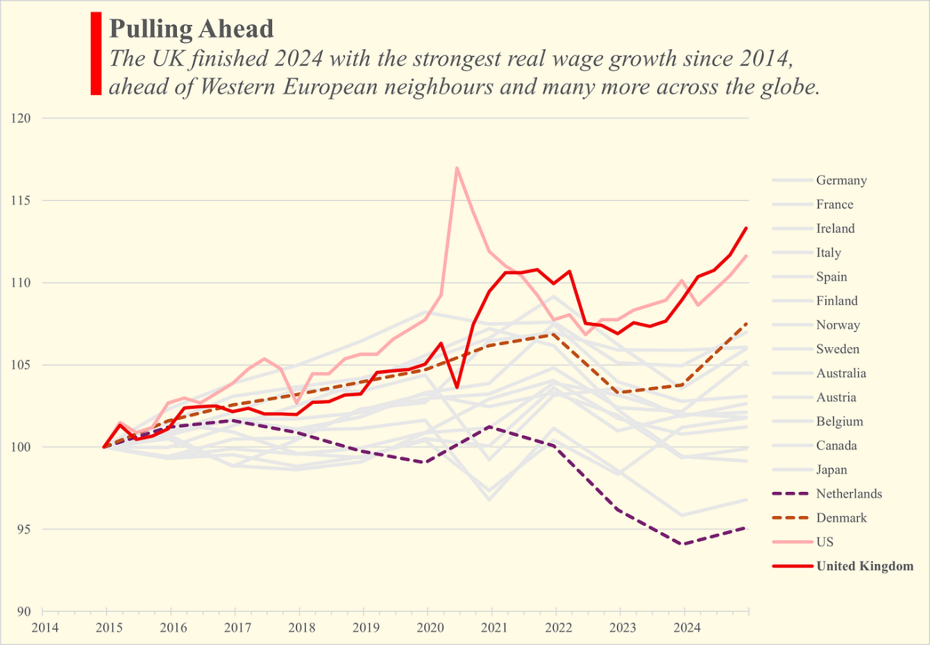](https://substackcdn.com/image/fetch/$s_!gP1U!,f_auto,q_auto:good,fl_progressive:steep/https%3A%2F%2Fsubstack-post-media.s3.amazonaws.com%2Fpublic%2Fimages%2F9900411b-e57f-42a9-a8b8-dedae3ebce40_2801x1945.png)](https://substackcdn.com/image/fetch/$s_!gP1U!,f_auto,q_auto:good,fl_progressive:steep/https%3A%2F%2Fsubstack-post-media.s3.amazonaws.com%2Fpublic%2Fimages%2F9900411b-e57f-42a9-a8b8-dedae3ebce40_2801x1945.png" \t "_blank)

*Chart 3 – Own illustration. Source: OECD, ONS, FRED.*

Unlike the UK, many of these countries did not see a large fall in real incomes following the 2008 crisis – it is arguably easier to cut the slack and regain ground than it is to push past old limits. There is certainly still more work to be done if pay is to fully catch back up to the accumulated productivity growth since the late 80s. At the same time, it is undeniable that this growth represents the manifest success of Britain’s policymakers and her institutions. Minimum wage increases – rather than leading to unemployment or inflation – have meant that the lowest earning 15% of employees have seen their purchasing power grow the fastest, at up to 23%.

[[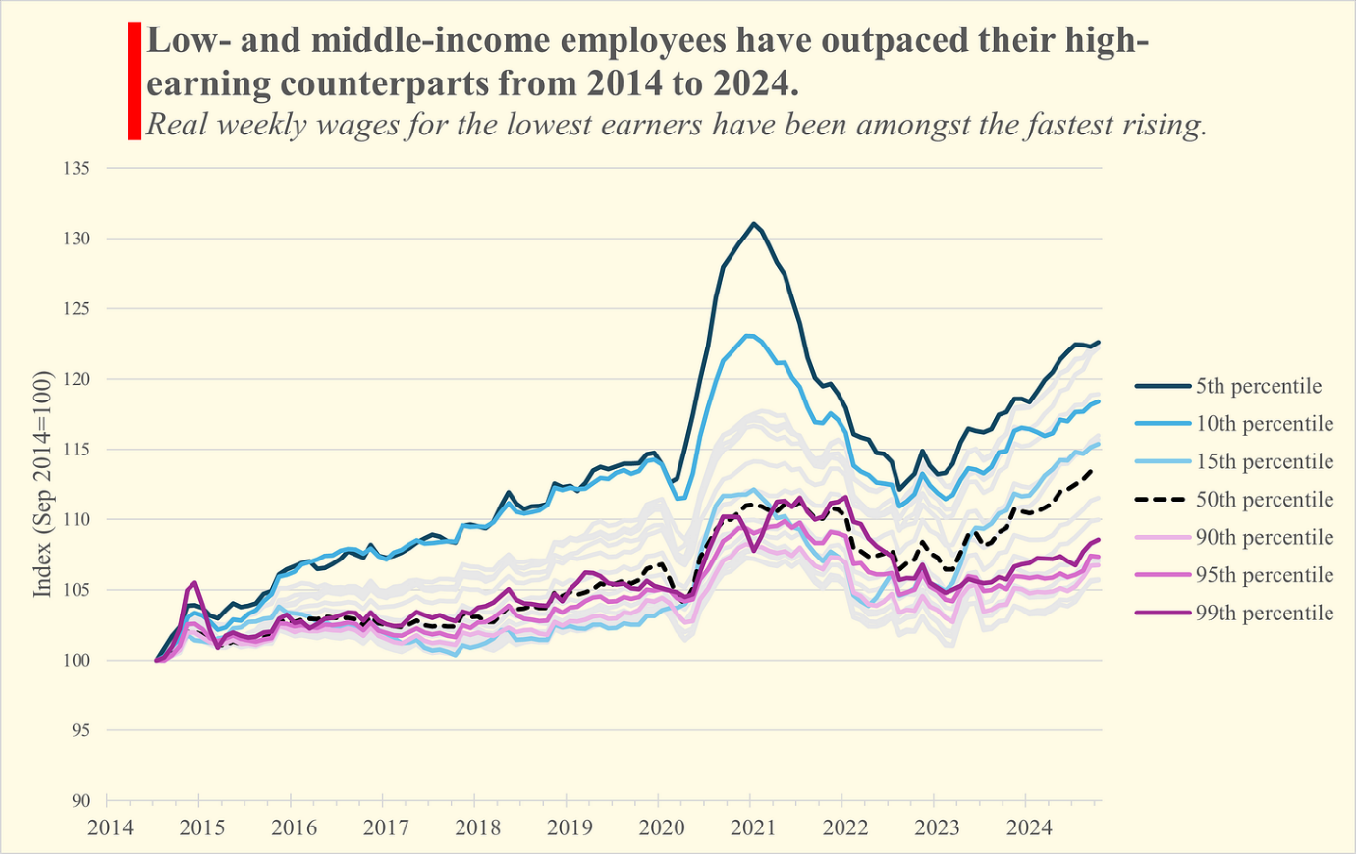](https://substackcdn.com/image/fetch/$s_!XLHv!,f_auto,q_auto:good,fl_progressive:steep/https%3A%2F%2Fsubstack-post-media.s3.amazonaws.com%2Fpublic%2Fimages%2F32935cfa-3c5d-4bc2-b07c-b00122a319a3_2952x1868.png)](https://substackcdn.com/image/fetch/$s_!XLHv!,f_auto,q_auto:good,fl_progressive:steep/https%3A%2F%2Fsubstack-post-media.s3.amazonaws.com%2Fpublic%2Fimages%2F32935cfa-3c5d-4bc2-b07c-b00122a319a3_2952x1868.png" \t "_blank)

*Chart 4 – Own illustration. Source: ONS*

Naturally, rising wages and benign productivity growth means the gap between the two has shrunk. The surprising fact is that the minimum wage increases and the general shift away from high-earners and towards the middle and short end of the income distribution only accounts for one third of this shrinking. From 2014 to the early months of 2025, the median rose 14% whereas the average rose only 11%.

[[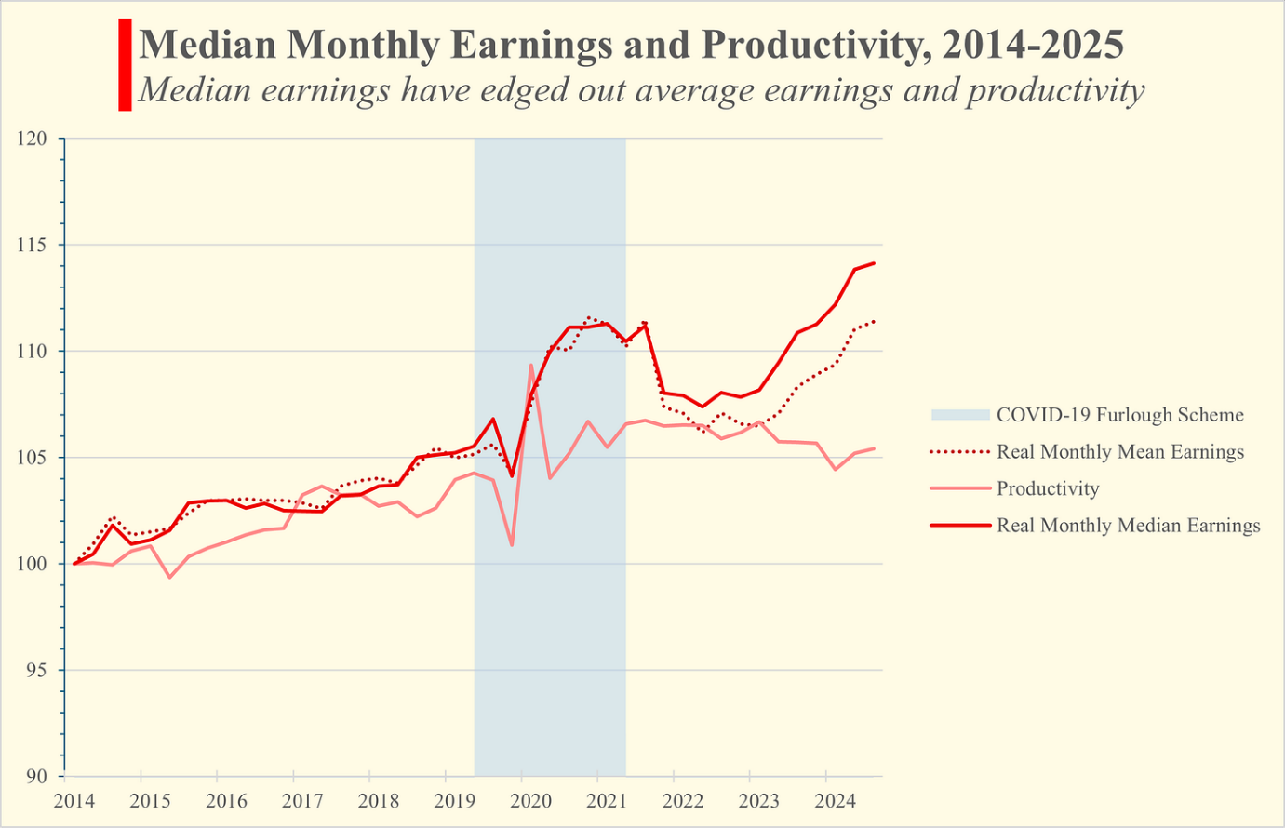](https://substackcdn.com/image/fetch/$s_!7P0R!,f_auto,q_auto:good,fl_progressive:steep/https%3A%2F%2Fsubstack-post-media.s3.amazonaws.com%2Fpublic%2Fimages%2F317a97df-8dda-411f-bbc2-2ca124d7bdf4_2535x1634.png)](https://substackcdn.com/image/fetch/$s_!7P0R!,f_auto,q_auto:good,fl_progressive:steep/https%3A%2F%2Fsubstack-post-media.s3.amazonaws.com%2Fpublic%2Fimages%2F317a97df-8dda-411f-bbc2-2ca124d7bdf4_2535x1634.png" \t "_blank)

*Chart 5 – Own illustration. Source: ONS*

That 3 point difference represents a reduction in income inequality and the transfer of income from high wage to low wage employees. The other 11 points come from a transfer *to* workers, *from* employers.

[[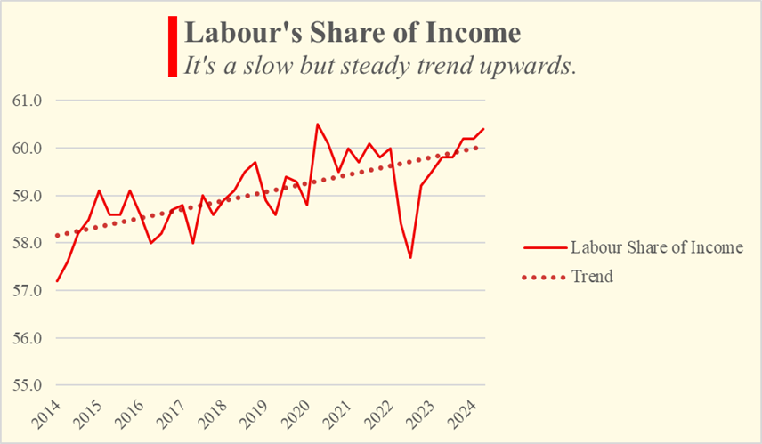](https://substackcdn.com/image/fetch/$s_!GO3p!,f_auto,q_auto:good,fl_progressive:steep/https%3A%2F%2Fsubstack-post-media.s3.amazonaws.com%2Fpublic%2Fimages%2F40e50fea-10b1-4fec-b7e0-28f7ac284cea_856x499.png)](https://substackcdn.com/image/fetch/$s_!GO3p!,f_auto,q_auto:good,fl_progressive:steep/https%3A%2F%2Fsubstack-post-media.s3.amazonaws.com%2Fpublic%2Fimages%2F40e50fea-10b1-4fec-b7e0-28f7ac284cea_856x499.png" \t "_blank)

*Chart 6 – Own illustration. Source: ONS*

With bated breath, both policymakers and critics watch the dance between pay and productivity. For the moment, signs are promising and wage growth is strong. While uninspiring productivity prevails, inspiring wage growth is only possible because of their divergence. When it’s working in reverse, perhaps the productivity-pay gap isn’t such a bad thing after all.

# Version II

Plan

* Better, catchier opening
* Since 2007 there has been a big rift: wages no longer follow productivity
  + There’s not much to follow.
  + Because productivity is so stagnant, it might actually be a good thing that wages can rise without it.

FOR the typical British worker, wages still haven’t returned to their peak in 2009. It has often been taken for granted that, when it comes to wage growth and rising living standards, labour productivity – that’s what the average worker produces in an hour – is everything. Or, as Paul Krugman, winner of the 2008 Nobel Prize in Economics, puts it, “almost everything.”

If this is the case, British wage growth is in trouble. In a conundrum called the ‘[productivity puzzle](https://www.economist.com/britain/2022/06/09/britains-productivity-problem-is-long-standing-and-getting-worse)’, labour productivity in the almost two decades since the 2008 financial crisis has remained flat, as seen in Chart 1, much to the disappointment of policy makers.

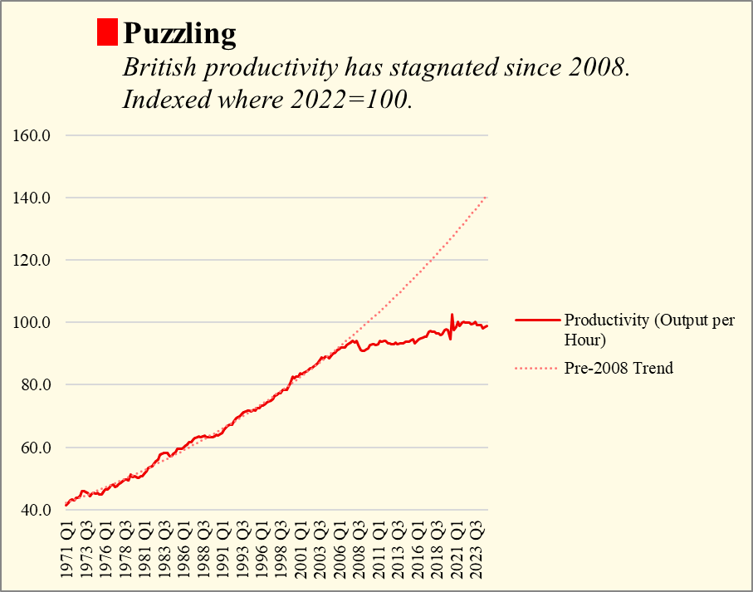

*Chart 1 – Own illustration. Source: ONS.*

Indeed, while earnings growth, and by extension living standards, was intertwined with productivity growth, their disconnection after 2008 is impossible to miss – see Chart 2.

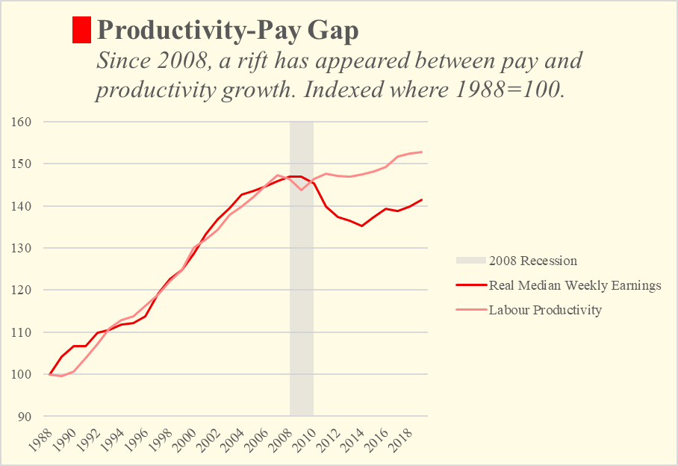

*Chart 2 – Own illustration. Source: ONS*

Chart 2 shows median earnings, which better represent the income of a typical employee than the average (i.e., mean), because they are not biased upwards by exceptionally high earners. The productivity-pay gap, a term coined by the Economic Policy Group, an American worker-oriented, non-partisan think tank, is the rift that has opened up between the growth of the two metrics across much of the Western world. It’s been widening in the US since the 1980s, but like many American phenomena it wasn’t too long before it gained a foothold in the UK and Europe.

Research has been done to understand the causes of the discrepancy following the recession. Professor John van Reenen, who now acts as an economic advisor to the Chancellor of the Exchequer, Rachel Reeves, published a study with co-author Andreas Teichgraeber in 2021 suggesting that the two main reasons for decoupling have been growing inequality and the rise of non-wage benefits.

Rising income inequality reduces the benefits of productivity growth for a few reasons. Lower-income workers may be less productive in general, and their industries may lag behind the average productivity of the wider economy. On the other hand, even if lower-income workers are productive, their more precarious position may mean that they don’t have the bargaining power to demand higher wages. New evidence has also emerged from a study published by Rachel Ngai and Orhun Sevinc in 2023, examining low-wage industries in the US. It suggests that, even when these industries compensate productive workers with a larger share of profits, if the prices charged by these industries rise slower than consumer prices, the extra revenue distributed to workers will not be able to offset inflation. In the UK, for example, the prices that manufacturing and service sector industries received didn’t rise as quickly as consumer prices.

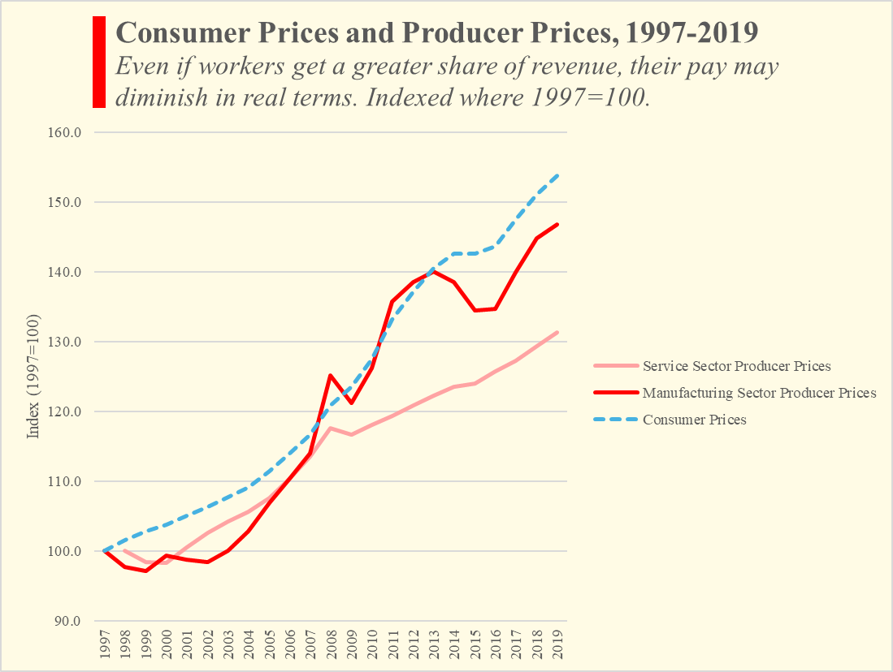

*Chart 3 – Own illustration. Source: ONS*

It may come as a shock, then, that since 2014 British wage growth has outpaced our neighbours and much of the OECD. Combining median wages from the HMRC’s PAYE database, US median wages from those aged 16 and over, and mean wages from a broad basket of high-income countries, and controlling for inflation, the UK manages to edge out the US by 2%, with wages finishing roughly 13% higher after 10 years. Denmark, the next closest contender, finished 6% lower with 7.5% growth.

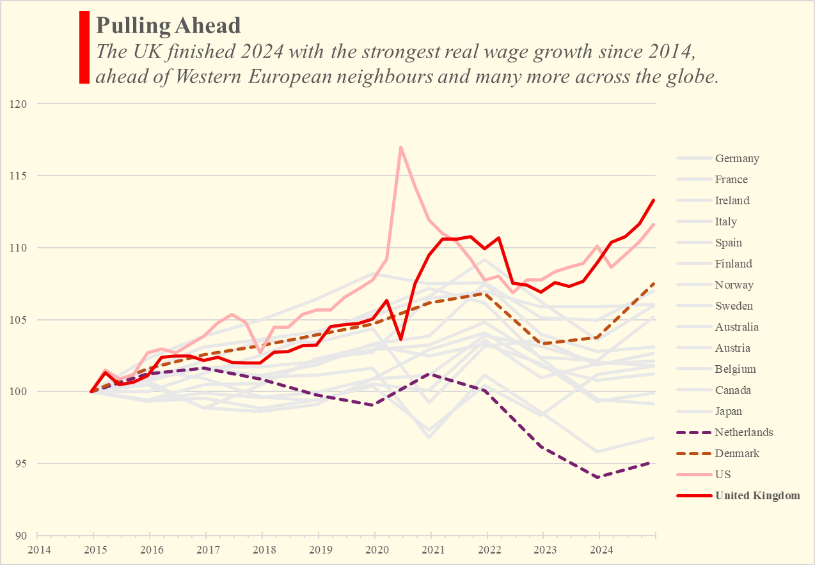

*Chart 4 – Own illustration. Source: OECD, ONS, FRED.*

Unlike the UK, many of these countries did not see a large fall in real incomes following the 2008 crisis – it is arguably easier to cut the slack and regain ground than it is to push past old limits. There is certainly still more work to be done if pay is to fully catch back up to the accumulated productivity growth since the late 80s. At the same time, it is undeniable that this growth represents the success of Britain’s policymakers and her institutions. Minimum wage increases – rather than leading to unemployment or inflation – have meant that the lowest earning 15% of employees have seen their purchasing power grow the fastest, at up to 23%.

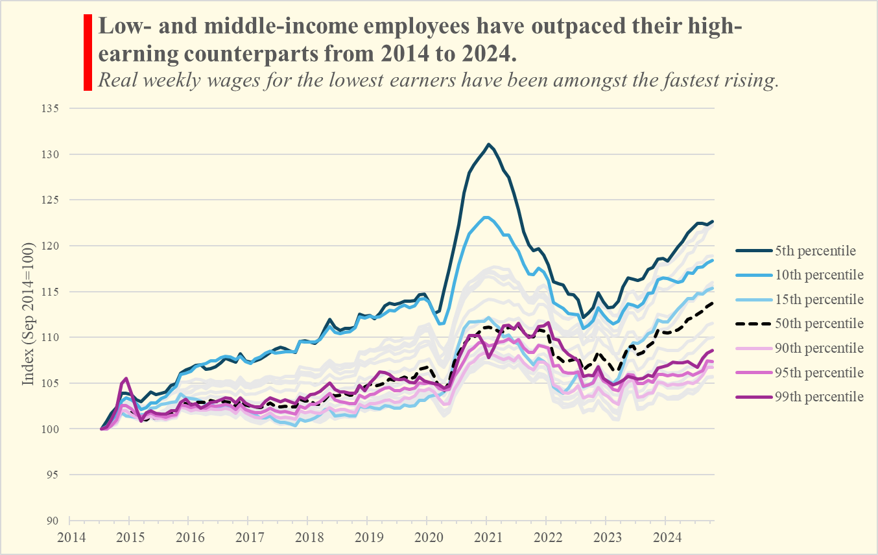

*Chart 4 – Own illustration. Source: ONS*

Naturally, rising wages and benign productivity growth can only mean that the gap between the two has shrunk. The surprising fact is that the minimum wage increases and the general shift away from high-earners and towards the middle and short end of the income distribution only accounts for one third of this shrinking. From 2014 to the early months of 2025, the median rose 14% whereas the average only rose 11%.

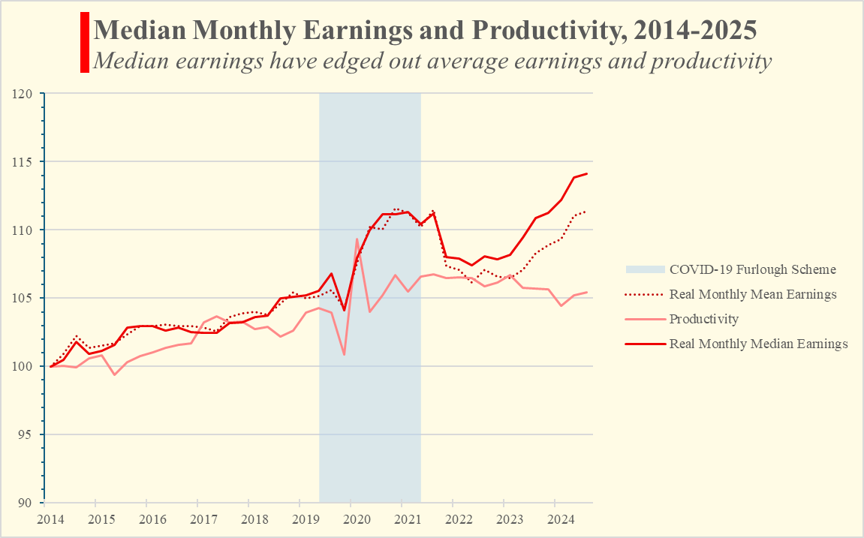

*Chart 5 – Own illustration. Source: ONS*

That means that two-thirds of the median wage growth, rather than being the result of a transfer *between* workers, comes from a greater rate of transfer *to* workers, from employers.

[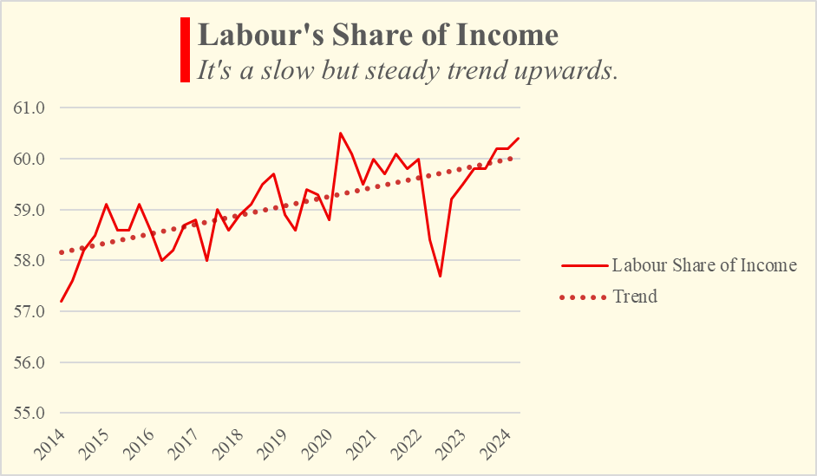](https://substackcdn.com/image/fetch/$s_!XIC1!,f_auto,q_auto:good,fl_progressive:steep/https%3A%2F%2Fsubstack-post-media.s3.amazonaws.com%2Fpublic%2Fimages%2F6433eac5-3988-449e-84e9-86165a97be7b_752x452.png" \t "_blank)

*Chart 6 – Own illustration. Source: ONS*

The dance of productivity and pay can be subtle at times. But signs are promising and wage growth is strong. In an age of uninspiring productivity, inspiring wage growth can only be achieved via their separation. When it’s working in reverse, perhaps the productivity-pay gap isn’t such a bad thing after all.

# Version I

In theory, labour productivity and wages are bound by a simple relationship. When the value we produce after working for an hour increases, our pay is supposed to follow soon afterwards. This view is not uncommon - in her [2024 Mais Lecture](https://labour.org.uk/updates/press-releases/rachel-reeves-mais-lecture/), Rachel Reeves said much of the same:

“At root, productivity remains the key medium term determinant of wages. It is the collapse in our productivity growth which explains our wage stagnation.”

To be crystal clear, she isn’t just referring to the average wage, which is often biased toward the higher end of earners. Reeves is referring to living standards in general, which economists, from Solow to Friedman to Krugman, agree are deeply intertwined with a nation’s productivity.

In recent years, however, a counternarrative has formed. Centred around the idea of ‘decoupling’, this new school of thought argues that because of tax cuts, stock buy-backs and growing inequality, a gulf has emerged between productivity and the median worker’s earnings. Indeed, from 1988 to 2019, productivity grew by around 53% whereas wages only rose by 41%.

[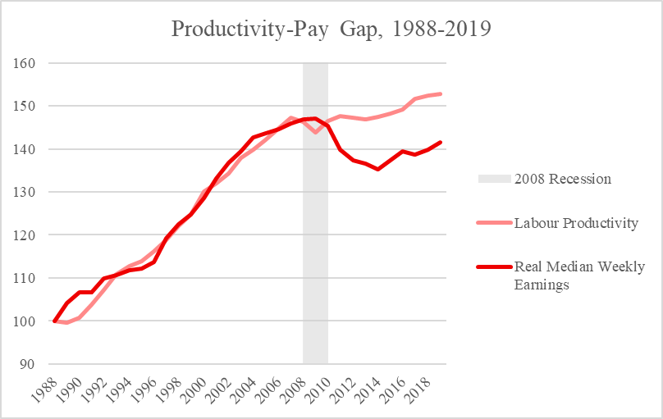](https://substackcdn.com/image/fetch/$s_!ZIJ6!,f_auto,q_auto:good,fl_progressive:steep/https%3A%2F%2Fsubstack-post-media.s3.amazonaws.com%2Fpublic%2Fimages%2F78cfdc87-61a8-45d8-bbac-c056620f86c9_808x511.png" \t "_blank)

*Source: Own Illustration. Data ONS’*[*1968-2023 Median Earnings Series*](https://www.ons.gov.uk/employmentandlabourmarket/peopleinwork/earningsandworkinghours/datasets/earningstimeseriesofmediangrossweeklyearningsfrom1968to2022)*and*[*Labour Productivity Flash Estimate*](https://www.ons.gov.uk/employmentandlabourmarket/peopleinwork/labourproductivity/articles/ukproductivityintroduction/januarytomarch2025andoctobertodecember2024#data-on-productivity-flash-estimate-and-overview)*.*

The decoupling theory doesn’t argue that productivity growth is futile in terms of living standards - it just de-emphasises it relative to growing inequality and weak labour bargaining power. The problem is that none of these metrics look particularly rosey. Despite the efforts of successive governments, the UK still finds itself in the midst of a [productivity puzzle](https://intothepeasoup.substack.com/p/gains-mean-growth).

[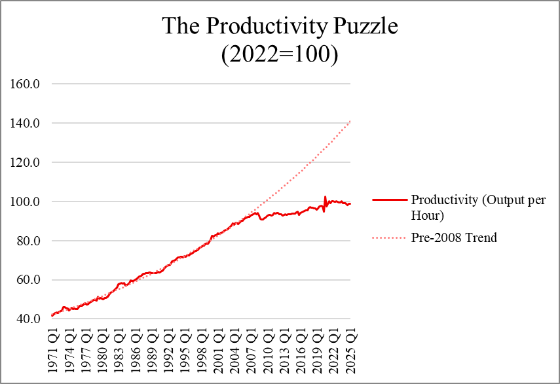](https://substackcdn.com/image/fetch/$s_!Pd0C!,f_auto,q_auto:good,fl_progressive:steep/https%3A%2F%2Fsubstack-post-media.s3.amazonaws.com%2Fpublic%2Fimages%2F4e5e950f-ea60-4bc4-8637-19b025cc03e6_855x587.png" \t "_blank)

*Source: Own illustration. Data from ONS’*[*Productivity Flash Estimate*](https://www.ons.gov.uk/employmentandlabourmarket/peopleinwork/labourproductivity/articles/ukproductivityintroduction/januarytomarch2025andoctobertodecember2024#data-on-productivity-flash-estimate-and-overview)*.*

As it stands, productivity would be about 40% higher if it had continued on its pre-2008 trend. Even if the relationship between productivity and pay isn’t one-to-one, the wage boost would be nothing to sniff at.

The [broad view on inequality](https://researchbriefings.files.parliament.uk/documents/CBP-7484/CBP-7484.pdf) from 1994 to 2020 suggests that income inequality, while largely stable, remains relatively high. The exact mechanism by which inequality impacts wage growth isn’t yet fully understood. It might be because low-earners are less productive and as such firms cannot afford higher wages. Or, low-earners may be largely productive, but don’t have the bargaining power necessary to negotiate for a raise. A recent study in the US by Rachel Ngai and Orhun Sevinc published in the *Review of Economic Dynamics* found that even if low-earners are productive *and* rewarded by firms, consumer prices might simply be rising too fast, relative to the revenue of low-wage industries.

It might come as something of a surprise, then, that the past decade has seen uniquely strong median wage growth.

[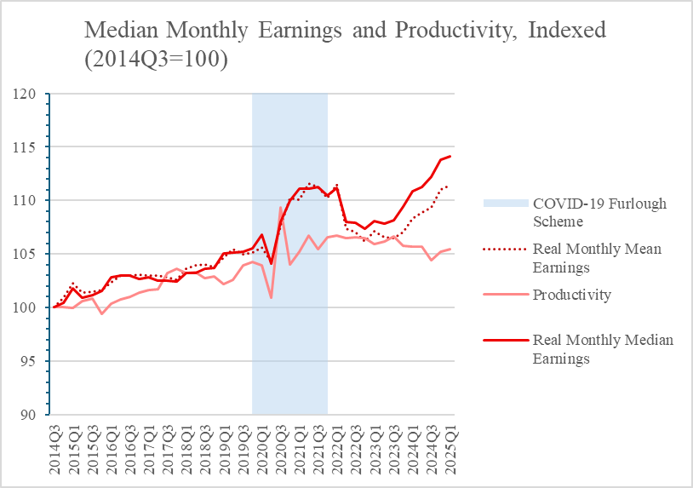](https://substackcdn.com/image/fetch/$s_!MaFN!,f_auto,q_auto:good,fl_progressive:steep/https%3A%2F%2Fsubstack-post-media.s3.amazonaws.com%2Fpublic%2Fimages%2F424d7a9a-b51f-48cb-beda-80ddd8c2cdea_814x573.png" \t "_blank)

*Source - Own illustration. Data from ONS’*[*Earnings and Employment*](https://www.ons.gov.uk/employmentandlabourmarket/peopleinwork/earningsandworkinghours/bulletins/earningsandemploymentfrompayasyouearnrealtimeinformationuk/june2025#median-monthly-pay)*page and the*[*Productivity Flash Estimate*](https://www.ons.gov.uk/employmentandlabourmarket/peopleinwork/labourproductivity/articles/ukproductivityintroduction/januarytomarch2025andoctobertodecember2024#data-on-productivity-flash-estimate-and-overview)*. Data is seasonally adjusted.*

Since 2014, real median earnings have outpaced productivity, at a rate of almost three-to-one. Inequality also reduced after the end of the COVID-19 Furlough programme, where the government spent roughly £70bn to ensure people would keep a steady income during the pandemic.

It’s nothing crazy - definitely not explosive growth in either metric, and we still have a ways to go before the gap can be closed for sure. The really surprising thing is that this quiet reversal of fortune isn’t even really due to shrinking inequality. Changes to inequality account for just over 30% of the ‘recoupling’. The real driving factor seems to be that the share of total income going toward workers has steadily trended upward in the last decade.

[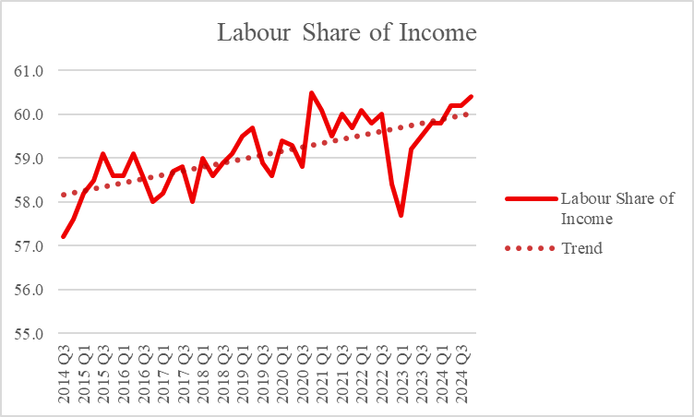](https://substackcdn.com/image/fetch/$s_!XIC1!,f_auto,q_auto:good,fl_progressive:steep/https%3A%2F%2Fsubstack-post-media.s3.amazonaws.com%2Fpublic%2Fimages%2F6433eac5-3988-449e-84e9-86165a97be7b_752x452.png" \t "_blank)

*Source - Own illustration. Data from ONS’*[*Labour Share of Income timeseries*](https://www.ons.gov.uk/employmentandlabourmarket/peopleinwork/labourproductivity/timeseries/fzln/ucst)*.*

The dance of productivity and pay can be subtle at times. But signs are promising and wage growth is strong. In an age of listless productivity, perhaps being able to separate one from the other isn’t such a bad thing after all.